**Clinical outcomes of orthologous heart transplant after implantation of left ventricular assist devices (LVAD) comparing time to transplant and the use of invasive hemodynamic monitoring**

**Running Title: OHT timing and characteristics after LVAD placement**

**Address for Correspondence:**David Ouyang, MD  
300 Pasteur Drive, L154  
Stanford, CA 94305  
Telephone: 832-495-1605  
Fax: **877-991-6506  
Email: Ouyangd@stanford.edu**

**Journal Subject Code:**

**Abstract**

**Background -** The optimal characteristics for orthologous heart transplant (OHT) after the implantation of left ventricular assist devices (LVAD) is unknown. There exists significant inter-center variation in the timing of OHT and use of invasive hemodynamic monitoring.

**Methods and Results** - With the Nationwide Inpatient Sample (NIS) from 1988 to 2011, we identified 2200 patients 18 years of age or greater who underwent implantation of a LVAD and for which day of procedures was available. On average, patients underwent first LVAD placement on day 9.4 of hospitalization and started invasive hemodynamic monitoring 7.2 days prior to LVAD placement. Patients who had invasive hemodynamic monitoring (n = 491, 22.32%) were not significantly different with respect to age (,gender ratio, # of concomitant diagnoses**), however waited longer for LVAD implantation (13.4 days vs. 8.5 days, p < 0.XXX) but had less in-hospital mortality (20.0% vs. 28.5%, p <0.XXX). 164 (7.5%) patients also underwent OHT during the same hospitalization, which occurred 32 days (IQR 7.75 - 66 days) after LVAD implantation. More mortality was seen in patients who underwent OHT within 7 days of LVAD implantation compared to patients who underwent later OHT (25% vs. 13%, p < 0.XXX) as well as compared to patients who did not receive OHT during the same hospitalization (25% vs. X%, p <0.XXX). ***  
**Conclusions** - Mortality is increased for patients who undergo heart transplant within 1 week of LVAD implantation compared to patients who did not receive OHT during the same hospitalization, patients who undergo OHT later during the same hospitalization, and patients who required secondary LVAD placement. Patients who undergo invasive hemodynamic monitoring appear to have better outcomes, however there can be selection bias as these patients could have also been waiting for OHT.

**Introduction**

**Methods**

**Data Source**

The Nationwide Inpatient Sample (NIS), from the Healthcare Cost and Utilization Project, Agency for Healthcare Research and Quality, is the largest database of all-payer inpatient discharge information, sampling approximately 20% of all non-federal US hospitals and including approximately 9 million hospital admissions each year. It contains discharge data from over 5000 hospitals located across 45 states each year, of which approximately 1,200 hospitals are sampled each year to create a statified sample of United States hospitals. Each NIS entry includes all diagnosis and procedure codes of activity during the patient’s hospitalization at the time of discharge, as well as patient demographics, hospital characteristics, and short-term complications of the hospitalization.

**Study design and Cohorts**

This was a retrospective cross-sectional study using the Nationwide Inpatient Sample (NIS) between 1988 and 2011. We identified all hospitalizations from 1988 to 2011 of patients 18 years of age or greater that underwent placement of a left ventricular assist device and for which the hospital day of each procedure was available. Procedures during the hospitalization in addition to LVAD placement, including orthologous heart transplant, extracorporeal membrane oxygenation, intubation, hemodialysis, invasive hemodynamic monitoring, cardiac catheterization, and reoperation were identified by associated ICD9 codes. Additionally, hospital mortality and perioperative morbidity such as post-operative infections, cardiopulmonary complications, and hemorrhagic complications were identified.

**Statistical Analysis**

Python 2.7 (Python Software Foundation, www.python.org) and R 2.13 (R Foundation, www.r-project.org) were used for statistical analysis.

**Results**

**Discussion**

**Funding Sources:** No study specific funding was used to support this work. The authors are solely responsible for the study design, conduct, and analyses, drafting and editing of the manuscript and its final contents.

**Conflict of Interest Disclosures:** None of the listed authors have any disclosures or potential conflicts of interest.

**References:**

Table 1: Baseline characteristics

Figure 1:

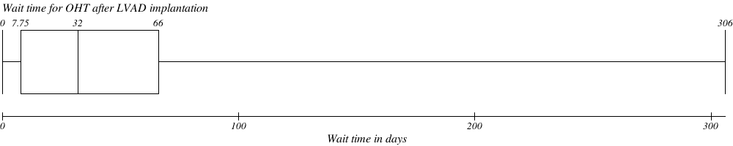

Table 3: